Carbon-Pollution Free (CFE) Data Entry Instructions

November 9, 2023
New CFE fields have been added to the Facilities-->Energy tab. These new fields only display when “Electricity” or “Natural Gas” are selected as the Energy “Subcategory”. The new CFE fields will assist SPO in calculating site progress towards CFE goals if a site is not using the eGRID mix.

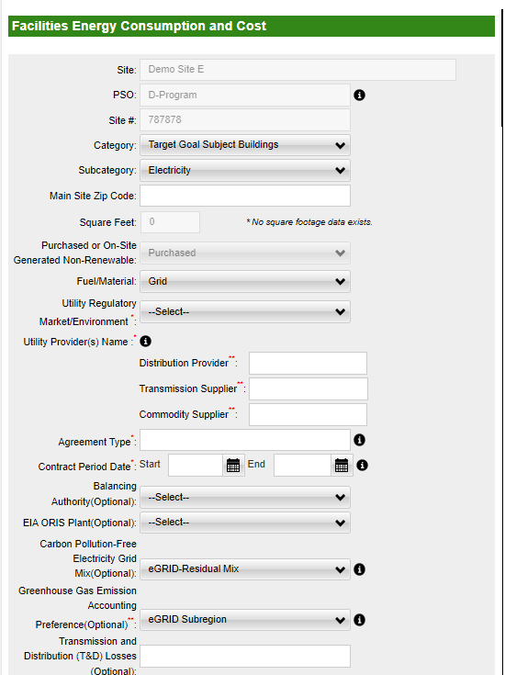

If you have already added energy data, but have not yet completed the module, “Select” your Energy entry. You will be able to see the new CFE fields with your onsite CFE characteristics.

If you have already approved your Energy data, you do not need to fill out the CFE fields by the November 17th deadline. This information can be added when the page is unlocked in February.

There is a new energy template that you can use that captures the additional CFE fields. If you are in the middle of your energy data entry and are using an upload template, please redownload the energy template, and copy and paste your entries to this template.

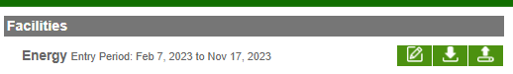
The below instructions document the new CFE fields.

- If selecting “Electricity” or “Natural Gas” within the Energy Subcategory, sites will be prompted with additional CFE fields. 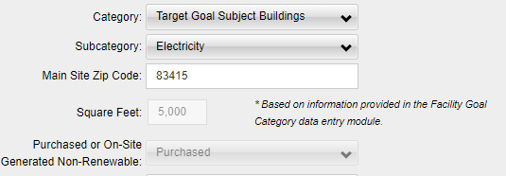

- Enter in the “Fuel/Material” used. Note this is only an option if you choose “Electricity” from the Subcategory. The dropdown contains “Combined Heat and Power”, “Conventional Hydro”, or “Grid” options. If you select “Combined Heat and Power”, you will be given an optional field to enter the “Plant Name”. 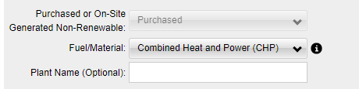

- Select your “Utility Regulatory Market/Environment. Choices include “Vertically Integrated”, “Retail Electric Choice”, “Mix”, “Not Available”.
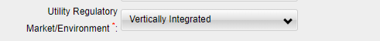

- Provide your “Utility Provider(s) Name”. You must at least provide the “Distribution Provider”, the “Transmission” Supplier or the “Commodity Supplier”. If these are the same provider, list the provider in each text field. 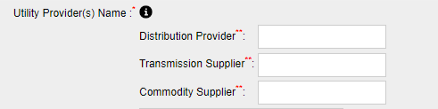

- Provide the “Agreement Type”. 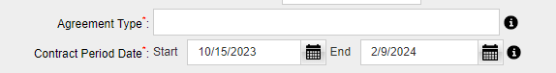
- Example agreement types include: General Service Administration (GSA) Areawide Task Order, Defense Logistics Agency/GSA Commodity Contract, West Area Power Administration Agreement, etc.
- Provide the “Contract Period Date”. This is the date when the contract was enacted with the utility. For every separate contract provider and period, be sure to create a new entry Energy entry and report the usage and cost separately.

- Choose the “Balancing Authority”. This is an optional field. If you do not know your balancing authority leave this blank. These EPA resources can help you identify your balancing authority.
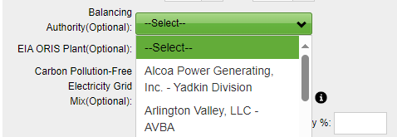

- Enter in the “EIA ORIS Plant” from the dropdown. This is an optional field, and if you do not know the plant name, leave the field blank. The Department of Energy’s Energy Information Administration (EIA) Office of Regulatory Information Systems (ORIS) Plant is a name associated with Plant ID code assigned by the EIA or the EPA’s Clean Air Markets Division which can be used to identify Greenhouse Gas Reporting Program facilities. The Energy Information Administration Plant ID code is also referred to as the “Plant ID”, "ORIS code", "ORISPL code", "Facility ID", or "Facility code", among other names. 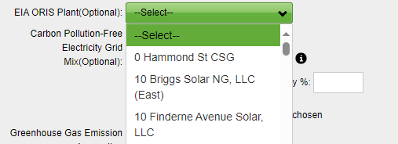

- Enter in the “Carbon Pollution Free Grid Mix” (Optional). Sites may choose between “eGRID-Residual Mix”, “Supplier Attested”, and “Site Estimate”. 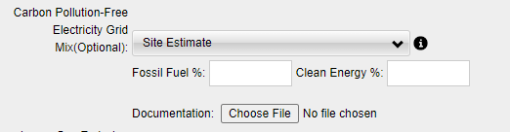

If you choose “Supplier Attested” or “Site Estimate” please provide documentation where we can see the breakdown of CFE from your suppliers. Suitable documentation must include:
- Fuel Type: such as hydro, solar, or wind. For both EPAct 203 and CFE these fuel sources count: solar, wind, hydrokinetic, marine energy, and geothermal. For EPAct 203, biomass, landfill gas, and MSW. While for CFE, nuclear, renewably sourced hydrogen, and electricity generated from fossil resources to the extent there is active capture and storage of CO2. Of note, new hydroelectric counts for EPAct 203. CFE does include hydroelectric but the distinction between old versus new versus hydroelectric old has not been noted.
- EAC/RECs only: Certification Vintage Period: MM/YYYY to MM/YYYY. For both EPAct Sec 203 and CFE the energy must be generated within 6 months to or 3 months after the current FY.
- Placed in Service Date: Month and Year. For EPAct Sec 203, 10 years or less from current FY can count, but for CFE it must be October 2021 or after.
- Location: Zip code. For EPAct Sec 203, there are no limitation but for CFE accounting, the system generating the power must be located in the same balancing area as the receiving site/location.

- Choose the “Greenhouse Gas Emission Accounting Preference” (Optional). If you choose “eGRID Subregion”, the emissions will be based off the eGRID region where your site located.
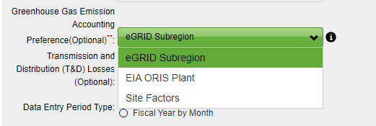
If you choose “ORIS Code”, it will be based of the region where the energy plant is located. Be sure to select the ORIS Code from the earlier dropdown. If you choose “Site Factors” you will have the opportunity to add your own mix. Enter this information in lbs/MWh for CO2, N2O and CH4.
