FY 2026 Site Energy and Water Management Narrative Instructions

Federal agencies must report annually to the Office of Management and Budget (OMB) on their compliance with initiatives to improve energy efficiency, reduce energy costs, lower greenhouse gas emissions, and increase savings for U.S. taxpayers ([EISA 2007 § 527](https://www.gpo.gov/fdsys/pkg/BILLS-110hr6enr/pdf/BILLS-110hr6enr.pdf) and [42 U.S.C. § 17143](http://uscode.house.gov/view.xhtml?hl=false&edition=prelim&req=granuleid%3AUSC-2012-title42-section17143&f=treesort&fq=true&num=0)). More information on these requirements and their citations can be found [here](https://sustainabilitydashboard.doe.gov/PDF/Resources/DOE%20Requirements%20Matrix%20Dashboard%202025_rev1.2.pdf). The Dashboard collects both the data and narrative necessary to report on the Department of Energy’s compliance with energy and water management requirements. The *Site Energy and Water Management Narrative Instructions* serve as a resource for reporting data and developing the narrative. This document is reviewed and revised annually to reflect updated requirements, Executive Orders (E.O.s), reporting process improvements, and to reduce ad-hoc data calls. Each year sites can start entering data into the Dashboard as early as February. Sites should ensure consistency between the narrative, reported Dashboard data, and other major documents and initiatives. This includes publications and data reported in other systems, such as the Federal Automotive Statistical Tool ([FAST](https://fastweb.inl.gov/)), Facilities Information Management System ([FIMS](https://fims.doe.gov/FIMS/)), Annual Site Environmental Reports, Federal Procurement Data System ([FPDS](https://www.fpds.gov/fpdsng_cms/index.php/en/)), and budget reports.

This document provides instructions for DOE sites to complete their FY 2026 Site Energy and Water Management Narratives. The instructions for FY 2026 have been streamlined to focus on information that is needed to complete statutory reporting requirements. Sites are **only** required to complete a narrative for Energy Management, Water Management, and Renewable Energy narrative sections if the reported year over year data fluctuates by more than ±5%. If there is a less than ±5% fluctuation, sites do not need to provide a narrative for each respective section. Sites are **only** required to fill out the *Investments: Facilities and Workforce* narrative if they have a relevant project. Like previous years, the narrative is due to the Dashboard within the *Energy Management, Water Management*, *Renewable Energy,* and the *Investments: Facilities and Workforce* sections of the narrative module. The narrative requirements for *Executive Summary, Waste Management, Fleet Management, Sustainable Buildings, Acquisition & Procurement, Indirect Emissions, Fugitives & Refrigerants,* *Electronic Stewardship & Data Centers, and Adaptation & Resilience* are all optional and will be marked in the Dashboard accordingly. Additionally, the supplemental *Sustainable Acquisition Contracts Workbook* and the *Biobased Product Purchasing Workbook* are both optional as well.

To submit the FY 2026 narrative, sites will use the narrative module in the Dashboard and approve their plan via the Dashboard’s completion process. **Direct entry into the Dashboard is required.** The name of the narrative module has changed to align with its purpose of gathering relevant narrative information necessary for reporting. If you wish to enhance the format of the narrative, please enter information in the Dashboard’s narrative module, then download the report and make any necessary formatting changes. Sites can then upload this new version as a Word or PDF with supporting documents to the Executive Summary category of the narrative module. The Dashboard data and the narrative are both due **November 21, 2025.**

Due to resource constraints, there will be no Kick-Off Call, New User Training, or weekly Open Line Help Calls as there have been in past years. To help with required reporting, sites are encouraged to review resources within the Dashboard’s *Supporting Resources* page. This page includes popular topics such as a New User Training video, the Dashboard User Guide, and the Dashboard approver training. Additionally, Dashboard training tutorials as well as other resources to aid in reporting can be found on the Dashboard’s Supporting Resources page. If time allows, these resources will be updated to reflect FY 2026 reporting instructions and recent changes to the Dashboard.

For questions regarding reporting, please email [sustainability@hq.doe.gov.](mailto:sustainability@hq.doe.gov) This inbox will be monitored and triaged, with questions related to statutory reporting requirements being prioritized.

Below are the required narrative sections that sites must report on if the data differs by more than ±5% year over year:

1. **Energy Management**
   1. **Goal Subject Buildings**

Discuss any extenuating factors that may be skewing site progress toward the energy intensity reductions reported in FY 2025. Explain any variances of greater than 5% from the prior year in British thermal unit (Btu), gross square footage (GSF), or Btu/GSF.

*Example: In FY 2025, Hawkins National Laboratory experienced a very cold winter which resulted in increased natural gas consumption for space heating. FY 2024 was a more typical winter, resulting in an increase of about 20 percent in natural gas consumption year over year.*

* 1. **Goal-Excluded Facilities**  
     Explain any variances of greater than 5% from the prior year in Btu consumed or gross square footage of goal-excluded facilities.

*Example: Hawkins’ supercomputer came online in FY 2024 and was fully functional in FY 2025. The supercomputer is projected to double campus electricity consumption.*

* 1. **Vehicles and Equipment**

Discuss trends pertaining to this category of fuel use for non-fleet vehicles and other equipment not captured by the Federal Automotive Statistical Tool (FAST) reporting system. Explain any variances of greater than 5% from the prior year in Btu consumed.

*Example: Hawkins completed large-scale construction of its new research campus in FY 2025. As a result of the completed construction, total non-fleet V&E energy consumed dropped by more than 25 percent.*

1. **Water Management** 
   1. Discuss any extenuating factors that may be skewing site progress toward potable water intensity reductions reported in FY 2025. Explain any variances of greater than 5% from the prior year in gallons (Gal), GSF, or Gal/GSF.

*Example: Hawkins decreased its potable water use intensity by 8 percent compared to FY 2024 and by 40.5 percent compared to the FY 2007 baseline. Hawkins continues to implement water conservation and efficiency measures. The large YOY decrease can mostly be attributed to a large leak fix in FY 2025.*

1. **Renewable Energy** 
   1. **On-Site Generated Renewable Energy**  
      Explain any variances of greater than 5% from the prior year in renewable electricity generated from on-site projects. If applicable, highlight specific recent projects contributing to increases in on-site generation from renewable energy.

*Example: Hawkins installed solar panels on the roof of its newly constructed Intraplanetary Parallel Processing Laboratory building; as a result, on-site renewable energy increased by 9%.*

* 1. **Purchased Renewable Energy**  
     Discuss highlights of major purchases and approaches taken to obtain renewable energy through purchases which may have contributed to a variance of greater than 5% from the prior year.

*Example: In FY 2025, Hawkins decreased purchased energy through Renewable Energy Certificate (REC) purchases by 34%. This was primarily because REC prices increased to $40 per MWh, making the purchase of RECs prohibitive.*

Sites are required to report on the narrative below if they have a project:

**Investments: Facilities & Workforce**

If you have a project, provide summary highlights of the following investment strategies undertaken during FY 2025 to implement efficiency measures and renewable energy projects Typically these projects are identified as part of EISA audits of which 50% are supposed to be funded via ESPCs within two years of identification:

* 1. Direct Agency Obligations: Discuss energy/water projects funded by annual appropriations during the FY.
  2. Energy Savings Performance Contracts (ESPC): Discuss any new ESPCs or ESPC task orders executed during the FY. Data should be collected directly from FEMP or the relevant program office (you may need to consult the Contracting Officer).
  3. Utility Energy Services Contracts (UESC): Discuss any new UESCs or UESC task orders executed during the FY. Data should be collected directly from FEMP or the relevant program office (you may need to consult the Contracting Officer).

*Example: Hawkins executed the second task order of its ESPC in FY 2025, with an investment value (total project cost) of $11,800,100. The project consists of ECMs identified during its recent EISA audit, two rooftop solar PV installations, and a microgrid for the Psychokinetics Research Laboratory building.*

# **Appendix A – Resources**

Statutory Requirement Resources. These resources can be found within the

* [DOE Energy and Water Management Requirements Matrix](https://view.officeapps.live.com/op/view.aspx?src=https%3A%2F%2Fsustainabilitydashboard.doe.gov%2FPDF%2FResources%2FDOE%2520Requirements%2520Matrix%2520Dashboard%25202025%25207.9.25.docx&wdOrigin=BROWSELINK)
* [DOE Energy and Water Management Goals Table](https://view.officeapps.live.com/op/view.aspx?src=https%3A%2F%2Fsustainabilitydashboard.doe.gov%2FPDF%2FResources%2FGoals%2520Table%25207.9.2025.docx&wdOrigin=BROWSELINK)
* [DOE Energy and Water Management Reporting Requirements Crosswalk](https://view.officeapps.live.com/op/view.aspx?src=https%3A%2F%2Fsustainabilitydashboard.doe.gov%2FPDF%2FResources%2FReporting%2520Requirements%2520Crosswalk%25207.9.2025.xlsx&wdOrigin=BROWSELINK)

Dashboard Training Resources:

* [Dashboard Overview](https://sustainabilitydashboard.doe.gov/PDF/Resources/Sustainability%20Dashboard%20Overview-1.pdf)
* [DOE Dashboard User Guide](https://sustainabilitydashboard.doe.gov/PDF/Resources/FY%202024%20Dashboard%20User%20Guide%20Version%201.5.pdf)
* [Data Entry](https://sustainabilitydashboard.doe.gov/Resources/SupportingResources.aspx?cat=2)
* [QA/QC and Change Requests](https://sustainabilitydashboard.doe.gov/Resources/SupportingResources.aspx?cat=2)
* [Creating a Report](https://sustainabilitydashboard.doe.gov/Resources/SupportingResources.aspx?cat=2)
* [2024 New User Training](https://sustainabilitydashboard.doe.gov/PDF/Resources/2024%20New%20User%20Training.pdf)
* [2024 HQ and Site Office Dashboard Approver Training](https://sustainabilitydashboard.doe.gov/PDF/Resources/2024%20HQ%20and%20Site%20Office%20Dashboard%20Approver%20Training%20(slides).pdf)

*Note: We are aware that these resources may not reflect recent changes made to the Dashboard. Please review the date on each resource to determine when these resources were developed. As time allows, SPO will update these resources to align with recent changes.*

# **Appendix B – Reporting Schedule**

The following schedule shows the dates and deadlines for reporting into DOE’s Energy and Water Dashboard. Please ensure the accuracy of all data entries as this data is reported to Congress, OMB, and the White House Council on Environmental Quality (CEQ). Timely data submission is necessary to produce reports that meet Departmental reporting requirements. For each database or report, the closing or reporting deadline is highlighted.

**Table A.1 –** [Energy and Water Dashboard](https://sustainabilitydashboard.doe.gov/)

|  |  |
| --- | --- |
| **Date(s)** | **Action/Event** |
| February 2025 | Dashboard opened for FY 2025 data entry. |
| October 2025 | End of year FIMS basic facility information uploaded to Dashboard. |
| October 23, 2025 | (Optional) FY 2025 Biobased Product Purchases Workbook uploaded within the Narrative’s Acquisition and Procurement section of the Dashboard by sites. |
| November 21, 2025 | FY 2025 Dashboard data, including (optional) FY 2025 Sustainable Acquisition Contracts workbook, are due with appropriate level(s) of approval. If not using the Dashboard approval process, be sure to upload a completed Dashboard Data Accuracy Self-Certification. FY 2025 Energy and Water Management Narrative, Excluded Buildings Self-Certification, and optional Plan Signature Document are due with appropriate level(s) of approval. |
| November 22 – December 31, 2025 | MA team members may reach out to sites with questions or seeking follow-up information about site data or narrative. |

# **Appendix C – Reporting FAQ**

## General Dashboard

**Question:** How can I gain access to the Dashboard?

**Answer:**  The person who wishes to gain access needs to click on the “Register” tab in the upper right-hand corner of the Home Page and enter their email address. Then, they need to complete the required information on the next page, including agreeing to the terms and conditions. Additionally, the primary energy and water reporting contact for the site must email [sustainability@hq.doe.gov](mailto:sustainability@hq.doe.gov) indicating they approve access to the new user. Once both of these items are submitted, MA will approve the request.

**Question:** What is the data approval and certification process for my site?

**Answer:** Generally, site users submit, a site manager approves, then the site office approves, and the data are then considered final. Some sites have different approval steps. If you don’t use the approval process in the Dashboard, you must submit a Dashboard Data Accuracy Self-Certification Letter. You can submit the letter and check your approval structure in the dashboard under Data à Completion Status.

**Question:** How can I submit a change request?

**Answer:** Select the row you would like to edit. The data will populate the entry form but will be locked for editing. Click the “Create Change Request” button at the bottom of the page. The data entry form will unlock and allow for edits. Required: Enter a justification and one additional email address for a manager, site office, or headquarters official. Optional: Upload supporting documents. Submit your request. You can also view a video demonstrating these steps under Supporting Resources > Training Files. Note: You can’t submit a change request for the facility goal category because it comes from the FIMS database.

**Question:** Where can I find the template to do a bulk data upload?

**Answer:** Templates can be found for their respective module on the data entry page to the right of the “Enter Data” pencil icon. Please use the upload template from the Dashboard each year as updates may have been made from last year’s template. You can use the template OR enter data manually. Not that not all data entry modules have a template.

**Question:** Why do I have flagged data in QA/QC? How do I address the flagged data notification on my homepage? Why does the Dashboard flag ± 10% changes while the narrative calls for explaining changes that are just ± 5%?

**Answer:** The Dashboard automatically flags historical data anomalies. MA sets the threshold for flagging at ± 10% change from the previous year. Click on the review link to access flagged requests and select “Launch QA/QC” to see a graph depicting year over year changes. Please work on reviewing flags and prioritize correcting current FY data. If something is flagged based on historical data anomalies, site users should double check if the information is correct. If it is correct, submit a justification. If it is incorrect, users should submit a change request.

The Dashboard flagging capacity helps users’ possible errors in data and the threshold has been set at 10% to capture significant changes. The Energy and Water narrative instructions mimic FEMP’s Annual Energy Report guidance and will be used to help DOE understand factors driving Departmental data changes.

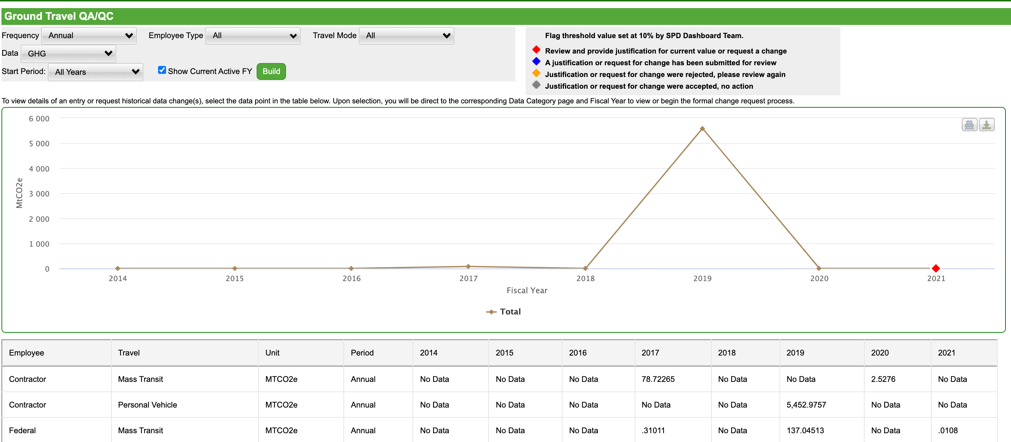

**Question:** How do I justify flagged data?

**Answer:** Access your flagged data, then select “Launch the QA/QC” to see a graph depicting year over year changes. Double click on the red diamond indicating the data you need to justify, add a justification, and submit. A Dashboard admin will approve the request.

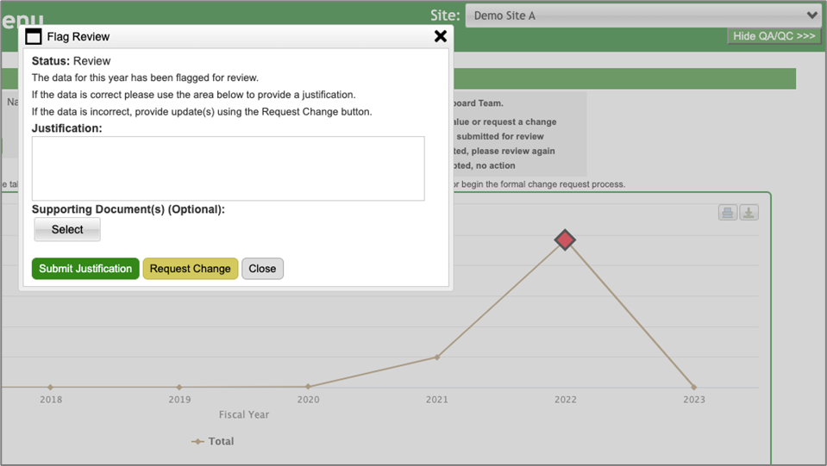

**Question:** Are there goals that sites should achieve in each respective data category?

**Answer:** Sites should work on improving efficiency year over year for relevant data categories (e.g., reduce water use intensity in FY 2026 from FY 2025.) SPO has developed a list of goals that align with statutory requirement compliance.For more information on these energy and water management goals, please consult the [DOE Energy and Water Management Goals Table](https://view.officeapps.live.com/op/view.aspx?src=https%3A%2F%2Fsustainabilitydashboard.doe.gov%2FPDF%2FResources%2FSustainability%2520Goal%2520Table%25206.17.2025.docx&wdOrigin=BROWSELINK).

**Question:** Will the Comprehensive Scorecard and OMB Scorecards be updated to reflect these goals?

**Answer:** Due to limited resources and other development priorities, updating these features is not a top priority. Please work to achieve YOY progress in relevant data categories.

**Question:** Have there been name changes to reflect new Administration priorities?

**Answer:** There have been several name changes to align with Administration goals, including the name of the Dashboard itself. That Dashboard is being rebranded as the Energy and Water Dashboard. In addition, there have been name changes to several data and narrative categories reflected below:

**Data Entry Pages**

Modules:

* Investments: Improvement Measures, Workforce & Community à Investments: Facilities & Workforce

Data Categories:

* On-Site Clean & Renewable Generation Systems à On-site Renewable Generation Systems
* Purchased Clean & Renewable Energy à Purchased Renewable Energy

Narrative Module: Site Sustainability Plan Home à Narrative Home

Narrative Categories:

* Clean & Renewable Energy à Renewable Energy
* Investments: Improvement Measures, Workforce & Community à Investments: Facilities & Workforce

## Data Module

**Question:** Which data entry sections are required vs. optional?

**Answer:** The following sections are required for reporting:

* Energy
* Water
* Onsite Renewable Generation Systems
* Purchased Renewable Energy
* Facility Goal Category
* Facility Metering Status
* EISA S432 Evaluations
* New/Major Renovation Building Design
* Municipal Solid Waste
* Wastewater Treatment
* Non-Fleet Vehicles & Equipment Fuel
* Fugitives & Refrigerants
* Efficiency & Conservation Measures
* Appropriations/Direct Obligations
* Training & Education

Please consult the DOE Energy and Water Management Reporting Requirements Crosswalk for more information on which data fields within these sections are specifically required.

## Narrative Module

**Question:** How do we know if the reported year over year data fluctuates by more than ± 5%, requiring our site to report for Energy Management, Water Management, and Renewable Energy narrative sections?

**Answer:** One way to determine if your year over year data differs by more than ± 5% is to go to the Comprehensive Scorecard section for your site. Once you have entered in your FY 2025, you will be able to see the % change from FY 2024. Please note that not all sections of the Comprehensive Scorecard are required reporting and that some required reporting is in categories outside of the Scorecard.

Figure 1: Navigate to the Comprehensive Scorecard but going to Reports--->Comprehensive Scorecard

Figure 2: Screenshot of the Energy Intensity section on the Comprehensive Scorecard. Once FY 2025data is entered, users will be able to see the % change from FY 2024.

**Question:** Which Energy and Water Management narrative sections are required vs. optional?

**Answer:** The following sections have been marked as optional from the Energy and Water Management Narrative instructions to streamline reporting.

* Executive Summary
* Waste Management
* Fleet Management
* Sustainable Buildings
* Acquisition & Procurement Narrative (Optional workbooks should still be uploaded to this page, if submitted)
* Indirect Emissions
* Fugitives & Refrigerants
* Electronic Stewardship & Data Centers
* Adaptation & Resilience

**Question:** How do I complete the Narrative?

**Answer:** Once you have checked the “Marked Complete” box for each narrative category, select the “Complete SSP” button. If you have the responsibility for approval, you will then have the option to “approve” or “reject” the narrative (on the right-hand side). The narrative can also be approved via the Completion Status page and should have all levels of approval like the Dashboard data.

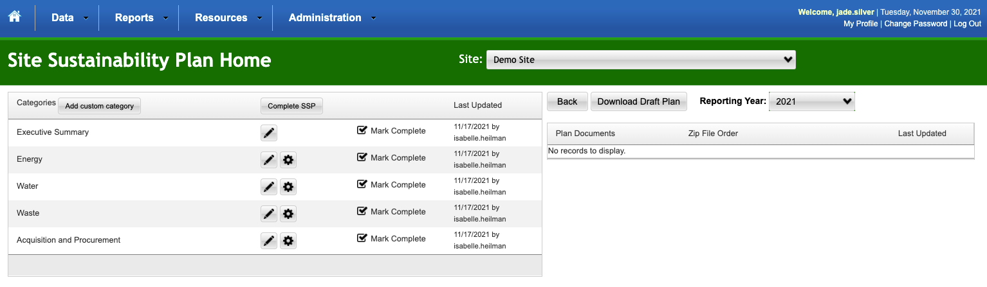

## Buildings

**Question:** Are the Guiding Principles for Sustainable Federal Buildings still a requirement?

**Answer:** E.O. 14057 has been rescinded, and with it the requirement for buildings over 25,000 gross square feet to meet the Guiding Principles. Sites must still report their sustainable buildings metrics into FIMS, as required by FIMS instructions.

**Question:** Will DOE continue to require buildings to use EPA’s Portfolio Manager to report and track energy usage?

**Answer:** Please continue to use Portfolio Manager if it is available.Reporting into Portfolio Manager is required as long as the system is available.

## Resilience

**Question:** Was the Resilience Solution Tracking module removed?

**Answer:** The Resilience Solution Tracking Module (Optional for Data Entry) has moved under the Investments: Facilities & Workforce Data entry section.

**Question:** Are sites expected to continue to develop Vulnerability Assessments and Resilience Plans (VARPs)?

**Answer:** No, sites are no longer expected to update their VARPs.

**Question:** Will DOE be updating the Climate Adaptation and Resilience Plan (CARP)?

**Answer:** No, E.O. 14008 was rescinded and DOE has no plans to write another CARP.

## Acquisition & Procurement

**Question:** When and how do I use the Sustainable Acquisition Contracts Workbook?

**Answer:** For FY25 reporting, the workbook is optional, but sites are welcome to still complete and submit the workbook. All service and construction contract actions that cannot be reported in the Federal Procurement Data System (FPDS) should be reported in the Sustainable Acquisition Contracts Workbook. Do not submit twice. The workbook can be found within the Supporting Resources section of the Dashboard. Please work with your site's Contracting Officer to ensure FPDS is not already being utilized. If you have any questions, please reach out to Shab Fardanesh in EHSS-21 at shabnam.fardanesh@hq.doe.gov.

**Question:** When do I use the Biobased Product Purchases Workbook?

**Answer:** For FY25 reporting, the workbook is optional, but sites are welcome to still complete and submit the workbook.If the original contract(s) has the “Recovered Materials/Sustainability” field coded for any of the available options that include the wording ‘bio-based”, then the Biobased Product Purchases Workbook should be submitted. The workbook can be found within the Supporting Resources section of the Dashboard. Please work with your site's Contracting Officer to ensure FPDS is not already being utilized. If you have any questions, please reach out to Shab Fardanesh in EHSS-21 at [shabnam.fardanesh@hq.doe.gov](mailto:shabnam.fardanesh@hq.doe.gov).

**Question:** Where do I submit the Sustainable Acquisition Contracts and Biobased Product Purchases workbooks?

**Answer:** The optional Sustainable Acquisition Contracts and Biobased Product Purchases workbooks are to be submitted to the Site Energy and Water Management Narrative module’s *Acquisition & Procurement* section under “Supporting Documents”

