Facility Metering Module Fact Sheet
- Sites are to report on their metering status ahead of the February 24th, 2023, reporting deadline. Information provided by sites will be used to inform a DOE-wide metering plan.
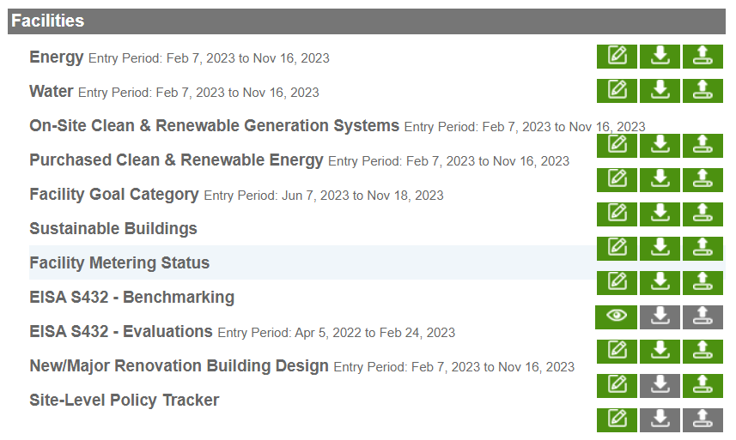
- SPD has revamped the metering section on the Dashboard. Past metering workbooks have been pre-populated in the new “Facility Metering Status” module for sites. SPD is still in the process of creating upload templates. Until these are created, sites should make metering changes directly in the Dashboard.
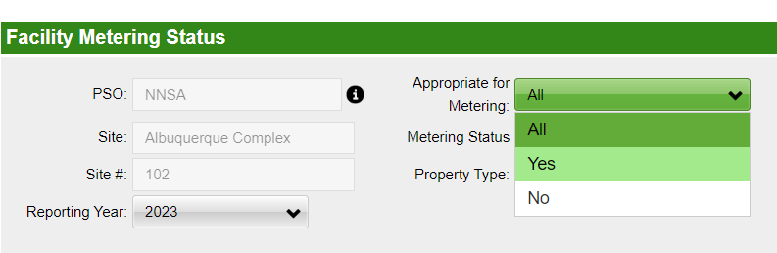
- Sites should report on metered assets for the 2023 reporting year. To streamline the reporting process, sites should select “Yes” from the “Appropriate for Metering” drop down. A list of “Appropriate for Metering” assets will appear.
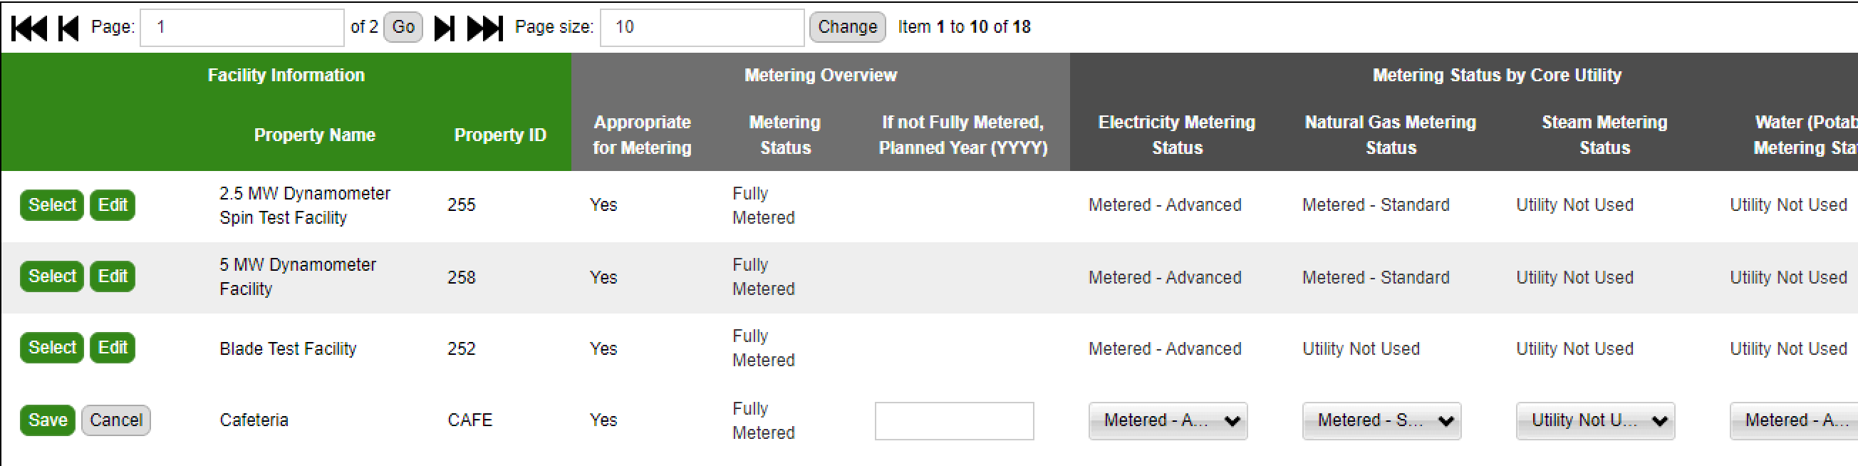
Sites should go through these assets and use the “Edit” button and corresponding drop-down picklists to indicate the utility metering status for electricity, natural gas, steam, and water. In addition, sites should indicate the year they expect each building to be fully metered in the “If not Fully Metered, Planned Year” column.
Note that if the overall metering status of the building is “Fully Metered” or “Metering Not Needed”, then there is no need to fill in the planned year. All buildings that are “Appropriate for Metering” should be updated.
  - We recognize that this is heavy lift, so add as many metering details as possible before the February 24th deadline reporting deadline.

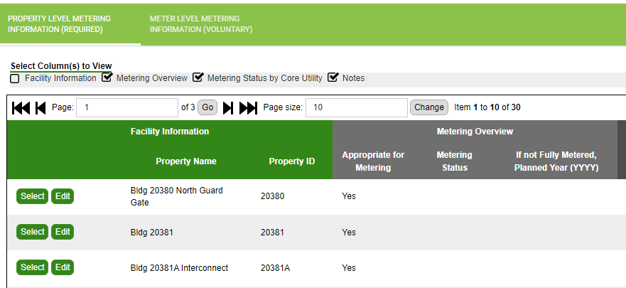
- If you pick the “Select” button for a facility, you will be taken to a different screen view where you can fill in additional metering status information. This information is optional and is not required for reporting. To adjust fields, ensure you navigate to the “Facility Metering Status” tab.
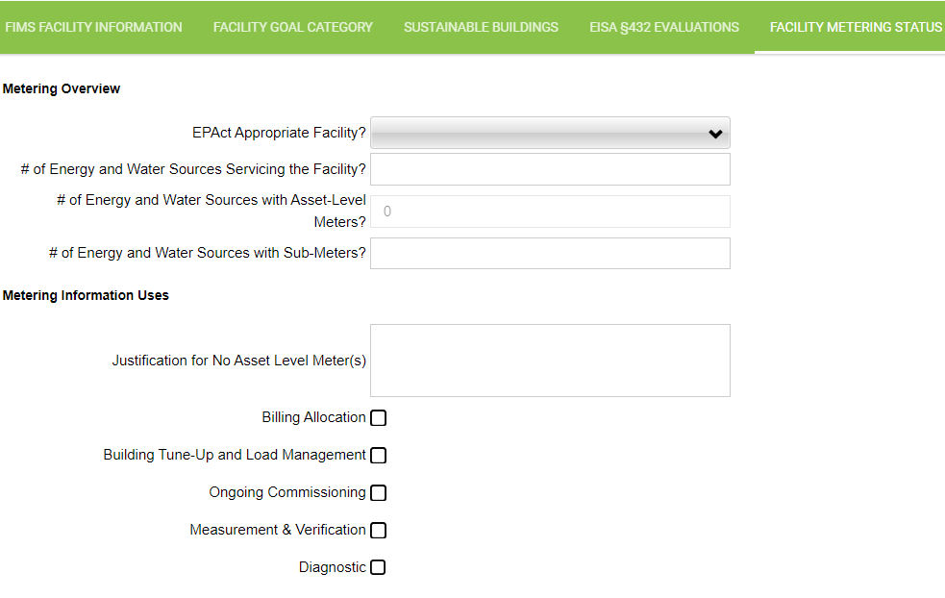

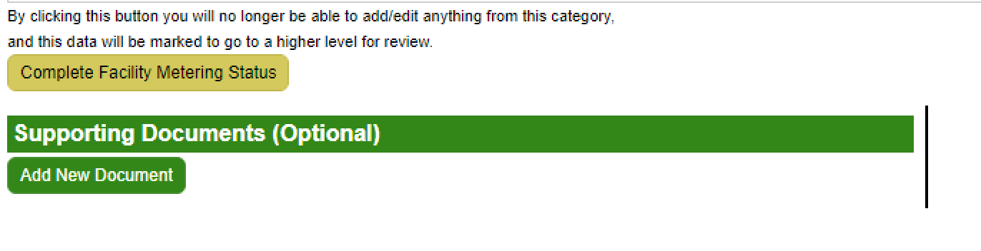
- Once finished filling in their metering data, sites should use the “Complete Facility Metering Status” button at the bottom of the page.
Metering FAQ
Q: What is the difference between facilities listed as “Appropriate for Metering” and “Not appropriate for Metering”.
A: If “Yes” is listed in the “Appropriate for Metering” column it means that building should be metered under the new FEMP metering guidance. SPD recommends you sort your metered assets by this field to help prioritize making data updates.

Q: We have some items that are showing as not appropriate for metering, but they are metered and super energy intensive. Should I just put a note in saying these assets should be metered?
A: These buildings may not fall under FEMP’s new metering guidance. If this is not the case, let SPD know.

Q: Is there any way to change the “Appropriate for Metering” category?
A: You cannot override the “Yes” or “No” in the appropriate for metering category, but you can put a justification for metering in the notes section. It is possible that mischaracterization could have happened and if so, then you can add this information to the notes. Please note we expect these mischaracterizations to be limited.

Q: Is the energy intensive threshold set by FIMS and not informed by former metering data?
A: Yes, this is data is pulled from FIMS.

Q: Is there a way to download all the info to review?
A: At this point you can create a report of metered facilities. SPD is still working on capability to upload metering data via excel templates.

Q: We have a lot of data to fill out and we are concerned we will not meet the Feb 24th deadline.
A: We understand the short deadline so have prepopulated as much data as we can. Work on getting as many as you can done.

Q: What conditions warrant the “minimal use” status instead of “not metered”?
A: An example might be a storage building that only uses electricity for basic lighting and for no other purposes (e.g., no HVAC system, no plug loads, etc.). In this case, because the electricity use in that building is small and straightforward, adding an electric meter would not provide much useful insight into managing the building’s electric load. Sites should use the “Minimal Use” designation very sparingly and should always provide a justification in the notes section whenever choosing “Minimal Use” for one of the four utilities.

Q: Are Minimal use and de minimums the same?
A: De minimums has a specific definition, so we have changed the terminology to “Minimal use”. Minimal use allows you to make a judgement call rather than using the exact definition.

Q: Why are chilled water meters missing from the reporting?
A: FEMP guidance does not require chilled water metering. We did not include them in the Dashboard to minimize the amount of data that was required to input into the system.

Q: Should we enter data under 2022 or 2023 reporting year? Once we enter in the data do we need to press the complete the button?
A: Report for 2023 and complete the data as you would like any other module, using the “complete

Q: What is the definition of an "Advanced meter"”
A: If the meter can collect on an interval basis (hour or less) it is an advanced meter and should have the ability to transmit data. Check out the FEMP metering guidance for more information.

Q: What if a building is listed as “No” for Appropriate for Metering but I believe it should be metered - At the end of the day, would best engineering judgement take precedence over the guidance?
A: In terms of requirements, you would not have to meter a building that shows up as “Not Appropriate for Metering”. However, at the site level, you may decide to meter a building based on your best judgement. You may use the Dashboard to enter metering information about a building that, under FEMP guidance, isn’t required to be metered.

